What is a VPN?

A VPN, or Virtual Private Network, allows you to create a secure connection to another network over the Internet. VPNs can be used to access region-restricted websites, shield your browsing activity from prying eyes on public Wi-Fi, and more.
VPNs essentially forward all your network traffic to the network, which is where the benefits – like accessing local network resources remotely and bypassing Internet censorship – all come from. Most operating systems have integrated VPN support.

When you connect your computer (or another device, such as a smartphone or tablet) to a VPN, the computer acts as if it’s on the same local network as the VPN. All your network traffic is sent over a secure connection to the VPN. Because your computer behaves as if it’s on the network, this allows you to securely access local network resources even when you’re on the other side of the world. You’ll also be able to use the Internet as if you were present at the VPN’s location, which has some benefits if you’re using pubic Wi-Fi or want to access geo-blocked websites.
When you browse the web while connected to a VPN, your computer contacts the website through the encrypted VPN connection. The VPN forwards the request for you and forwards the response from the website back through the secure connection.

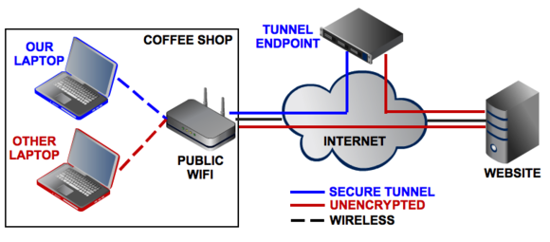Uses for VPNs
VPNs are a fairly simple tool, but they can be used to do a wide variety of things:
- Access a Business Network While Travelling: VPNs are frequently used by business travellers to access their business’ network, including all its local network resources, while on the road. The local resources don’t have to be exposed directly to the Internet, which increases security.
- Access Your Home Network While Travelling: You can also set up your own VPN to access your own network while travelling. This will allow you to access a Windows Remote Desktop over the Internet, use local file shares, and play games over the Internet as if you were on the same LAN (local area network).
- Hide Your Browsing Activity From Your Local Network and ISP: If you’re using a public Wi-Fi connection, your browsing activity on non-HTTPS websites is visible to everyone neraby, if they know how to look. If you want to hide your browsing activity for a bit more privacy, you can connect to a VPN. The local network will only see a single, secure VPN connection. All the other traffic will travel over the VPN connection. While this can be used to bypass connection-monitoring by your Internet service provider, bear in mind that VPN providers may opt to log the traffic on their ends.
- Access Geo-Blocked Websites: Whether you’re an American trying to access your Netflix account while travelling out of the country or you wish you could use American media sites like Netflix, Pandora, and Hulu, you’ll be able to access these region-restricted services if you connect to a VPN located in the USA.
- Bypass Internet Censorship: Many Chinese people use VPNs to get around the Great Firewall of China and gain access to the entire Internet. (However, the Great Firewall has apparently started interfering with VPNs recently.)
- Downloading Files: Yes, let’s be honest – many people use VPN connections to download files via BitTorrent. This can actually be useful even if you’re downloading completely legal torrents – if your ISP is throttling BitTorrent and making it extremely slow, you can use BitTorrent on a VPN to get faster speeds. The same is true for other types of traffic your ISP might interfere with (unless they interfere with VPN traffic itself.)

Pick your protocol
When choosing a networking protocol for your VPN, you need worry only about the four most popular ones. Here's a quick rundown, including the strengths and weaknesses of each.

Point-to-Point Tunneling Protocol (PPTP) is the least secure VPN method, but it’s a great starting point for your first VPN because almost every operating system supports it, including Windows, Mac OS, and even mobile OSs.
Layer 2 Tunneling Protocol (L2TP) and Internet Protocol Security (IPsec) are more secure than PPTP and are almost as widely supported, but they are also more complicated to set up and are susceptible to the same connection issues as PPTP is.
Secure Sockets Layer (SSL) VPN systems provide the same level of security that you trust when you log on to banking sites and other sensitive domains. Most SSL VPNs are referred to as "clientless," since you don't need to be running a dedicated VPN client to connect to one of them. They're my favorite kind of VPN because the connection happens via a Web browser and thus is easier and more reliable to use than PPTP, L2TP, or IPsec.
OpenVPN is exactly what it sounds like: an open-source VPN system that's based on SSL code. It's free and secure, and it doesn't suffer from connection issues, but using OpenVPN does require you to install a client since Windows, Mac OS X, and mobile devices don't natively support it.
In short: When in doubt, try to use SSL or OpenVPN. Keep in mind that some of the services highlighted in the next section don’t use these protocols. Instead, they use their own proprietary VPN technology.

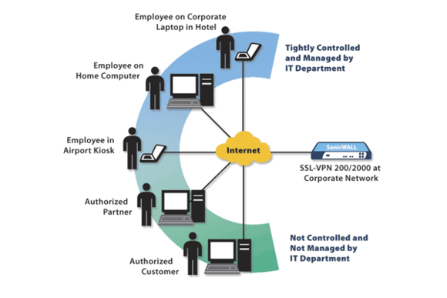

Now, let's talk about how to create and connect to your own VPN. If you want simple remote access to a single computer, consider using the VPN software built into Windows. If you’d like to network multiple computers together quickly through a VPN, consider installing stand-alone VPN server software.
If you need a more reliable and robust arrangement (one that also supports site-to-site connections), consider using a dedicated VPN router. And if you just want to use a VPN to secure your Internet traffic while you're on public Wi-Fi hotspots and other untrusted networks—or to access regionally restricted sites—consider subscribing to a third-party hosted VPN provider.

Reference
What is a VPN; http://www.howtogeek.com/133680/htg-explains-what-is-a-vpn/
How (and why) to set up a VPN today
http://www.pcworld.com/article/2030763/how-and-why-to-set-up-a-vpn-today.html

